**S.S.V.P.S.’s B. S. Deore Polytechnic, Dhule**

**Department of Computer Engineering**

**(Academic Year 2023-2024)**

**Cover Page**

**Title Page**

**MAHARASHTRA STATE BOARD OF TECHNICAL EDUCATION (MUMBAI)**

**INDUSTRIAL TRAINING REPORT**

**On**

**“Web Design & Development”**

**In partial fulfillment for the Completion of course**

**Industrial Training - 22049**

**in the Programme**

**Computer Technology**

**At**

**S.S.V.P.S’s B.S Deore Polytechnic, Dhule.**

**Academic Year 2023-24**

**Certificate From Institute**

**Certificate from Industry**

**Abstract**

Through the immersive courses on HTML, CSS, Bootstrap, JavaScript, and PHP at InnovationsHub Services Pvt.Ltd, Nashik. This presentation encapsulates the transformative experience of acquiring and applying vital web development skills in crafting an innovative project. Throughout the courses, we delved into front-end and back-end web development fundamentals, gaining comprehensive knowledge in building dynamic web pages, crafting appealing layouts, and implementing interactive functionalities. The "Shoe Website" mini-project served as the pinnacle of this learning journey, where we put our newfound skills to the test. The project aimed to design and develop an e-commerce platform. Leveraging the power of HTML, CSS, Bootstrap, JavaScript, and PHP, we successfully crafted an immersive online shopping experience, offering navigation, visually captivating designs, and robust back-end functionalities. In this presentation, we will explore the key highlights of the courses and the concepts learned during the course. Additionally, we will showcase the features of the "Shoe Website" mini-project, illustrating how the fusion of HTML, CSS, Bootstrap, JavaScript, and PHP develops a website.

**Acknowledgment**

**List of Figures**

**List of Tables**

**Chapter 1: Introduction**

* 1. **Introduction.**
* Welcome to the Industrial Training Course in Web Development! In this comprehensive program, we have explored HTML, CSS, Bootstrap, JavaScript, and PHP, the fundamental building blocks of modern web development.
* Throughout this journey, you have acquired they abilities to create visually captivating and interactive websites that not only engage users but also deliver seamless user experiences. From crafting elegant layouts with HTML and CSS to enhancing responsiveness with Bootstrap.
* Moreover, JavaScript has empowered you to create dynamic and interactive elements, bringing life to your web projects. The integration of PHP has enabled you to develop robust server-side functionalities.
* But learning is not complete without practical application. As part of this training, you have taken your newly acquired knowledge and put it into action by creating our very own website. From conceptualization to implementation, you have sharpen your skills by building a functional website, showcasing your skill in web development.

**1.2 Objectives of Implant Training.**

* Develop skills in analyzing the usability of a website.
* Understand how to plan and conduct user research related to web usability.
* Learn the language of the web: HTML and CSS. Assignments solved/Projects developed

**Chapter 2:Company’s Profile/Background**

* 1. **Introduction of Industry / Organization:-**

1. **COMPANY/ INDUSTRY PROFILE :-**

* **Name of the Company**: InnovationsHub Services Pvt Ltd
* **Location/ address** /**Pin code**: Reg. Office : 49, Vakratund Bunglow, Amrutdham, Nashik-422003, India
* **Establishment**: 2018
* **Email & Web Address**: www.innovationshub.in
* **Name and Designation of Owners / Contact Person:** Sachin Patil(Director)
* **Contact Number of Owners / Contact Person:** 9021721618
* **Type of Product:** Service Industry
* **Type of Control:** (Private )
* **Type of Company:** NA
* **Total Number of Employees in Company:** 22
* **Total Turnover of Company:** NA

**2.2 Type of Products and Services:**

Websites, Mobile Application, ERP, E-commerce, Online Marketing

Animation, Commercial Billing Software

**2.3 History :-**

Winner of the Smart India Hackathon 2022 (project-sponsored), organized by the

Ministry of Education (MoE).

* InnovationsHub creates technology solutions for retailers and commercial businesses to improve customer profitability.
* Develop POCs to test out new technologies and solutions.
* Industry Expertise: Healthcare, API Banking, Retail, Research and development.
* **Technology Highlights:**
  + Cloud Platforms (SaaS | Cloud SQL | Cloud Storage)
  + Data Modelling, NoSQL and Relational DBs
  + Web Services, Portals and Dashboards.
  + Mobile Apps and Experiences (Android | Cloud)
  + Digital Marketing(SEO | Social Media)
  + Training and Internship(Web | Android | Java | Python | AWS | Automation)

**2.4 Types of Major Software’s used in Industry/Organization with their specification:**

**1. Laptops:**

**Specification**

Processor: up to Intel Core i5-2410M 2.3 GHz.

* Graphics: ...
* Memory: up to 8GB DDR3.
* Storage: up to 750GB hard disk drive.
* Optical Drive: a dual layer DVD reader/writer.
* Display: 17.3" (HD, maximum resolution of 1600 × 900)
* Web Camera: integrated.

**2. Notepad++**

Notepad++ is a free, open-source text and source code editor. Written in the Web language, Notepad++ prides itself in paring down on unnecessary features and streamlining processes to create a light and efficient text notepad program.

**2. Local Server**

XAMPP is a free and open-source cross-platform web server solution stack package developed by Apache Friends, consisting mainly of the Apache HTTP Server.

**2.5 Organization Chart:**

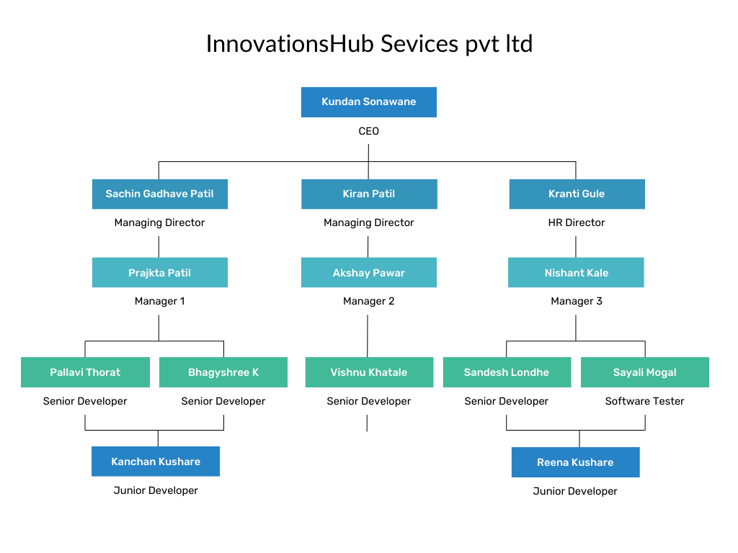

**Chapter 3: Weekly Job Summary**

# Week 1: From: 7 / 6 /2023 to 13 / 6 /2023

|  |  |
| --- | --- |
| **Day** | **Activities carried out** |
| 1 | * Web Design & Development. (Static and Dynamic Websites) * Difference between front end and backend * Introduction to HTML (hypertext markup language), Version upgradation, HTML structure. * Page Components: |
| 2 | * <!doctype html> Declaration of version HTML * <html> Container for the document </html> * <head><title> Title of the web page. </title></head> * <body> Content of the web page<body> * Heading tags (h1, h2, h3, h4, h5, h6) H1 – larger, H6 – smaller. * Paragraph tag :<p></p> |
| 3 | * Basic syntax and example of Image and Link * Image tag <img src = “url” alt = “description of Image”> * src: attribute where we can specify path of image. * alt: attribute where we can specify alternative name for image when image cannot be display. |
| 4 | * Lists * Ordered list <ol></ol> Unordered list <ul></ul> List tag <li></li> * Table tag <table></table> * Attributes in table tag: * <tr></tr>indicates table row. * <td></td>indicates table data. * Grouping tag: <div></div> |
| 5 | * Form: * Input tag :<input type=”text” placeholder=”name”> * type=”text” means it contains text value and placeholder is text you want into your text field. * type=”radio” used for radio buttons, type=”checkbox” used for checkbox, * type=”submit” used to submit form. * Select used to create list box and option attribute (<option></option>) used to insert values   in list. |
| 6 | * Used to insert a Div in an Html structure. * Div tag: <div></div> * Assignment-Basic website Page. |

**Weekly summarization of the above activities**:

In this week we first learned the difference between static and dynamic \. Additionally, we learned how to add Google Maps, audio, and video to websites. Also created a form with the use of a button, label,etc.

**Signature of the student:** ……………… **Signature of Industrial Supervisor: ……………….**

# Week 2: From: 14 / 6 /2023 to 20 / 6 /2023

|  |  |
| --- | --- |
| **Day** | **Activities carried out** |
| 1 | * Anchor tag <a></a> * Target attribute used to open link in new tab or the same To redirect in same tab. * target=”_self” * To redirect in new tab. * target=”_blank” |
| 2 | * Text Formatting : * Horizontal line tag <hr> * It is singular tag used to add horizontal line. * Bold tag <b> </b> Used bold text. * Super-script tags <sup></sup> * Sub-script tags <sub></sub> |
| 3 | * Introduction to CSS (Cascading style sheets) * Rules and types of CSS (Inline, Internal, External) |
| 4 | * Way of defining CSS: * Using Tag name: Use when we have only one tag. (e.g.: p{color: red;}) * Using Id: we use ‘#’ to write CSS for id. (e.g.: #name{height:50px;}) * Using Class name: we use ‘.’ To write CSS for class. (e.g.: .head{color: black;}) |
| 5 | * Color (color: “color name” ;) * Background Type: * background-color: “color name”; * background-image: url(“src”); * background-repeat: repeat-x, repeat-y, or no-repeat. |
| 6 | * Assignment-Design first website using Header, Article and Footer. |

**Weekly summarization of the above activities:**

We learned anchor tag and text formatting concepts also fundamentals of CSS in this week. We have also learned color properties and background properties.we have also design a basic Website using Header, Article and Footer

**Signature of the student:** ……………… **Signature of Industrial Supervisor: …………………**

# Week 3: From: 21 / 6 /2023 to 27 / 6 /2023

|  |  |
| --- | --- |
| **Day** | **Activities carried out** |
| 1 | * Text: font-size, font-family, font-style, text-shadow. * Text-align (Center, Right, Left, Justify) * Text-transform (Uppercase, Lowercase, Capitalize) * Text-decoration (none, underline, overline, line-through) |
| 2 | * Display: inline, block, inline-block, none. * Dimensions: width, height. * Overflow: hidden, scroll, visible, auto. Border: Parameters: Border-size, Border-style (dashed, solid, dot), Border-color.   (e.g.: “border: 2px solid color;”) |
| 3 | * Margin: outer space of content (margin: dimensions ;) * Padding: inner space of content (padding: dimensions ;) * Dimensions: top, right, bottom, left Same for both. |
| 4 | * Introduction to Bootstrap. * Online-bootstrap:<link rel="stylesheet" href="https://maxcdn.bootstrapcdn.com/bootstrap/3.4.0/css/bootstrap.min.css"> * Offline bootstrap: (download bootstrap file and include it in tag) |
| 5 | * Classes: Container and Container-fluid. * Grid: Grid is made up of grouping of Rows and Columns inside 1 or more Containers. * Used for layout, specifically Responsive Layouts. |
| 6 | * Jumbotron class: used to create a grey box. * Table class: table class = “table”. * table-bordered, table-striped, table-condense, table-responsive. * Image-classes: img-rounded, img-thumbnail, img-responsive, img-circle. |

**Weekly summarization of the above activities:**

In week 3 we have learned Text-align, Text-Transform and Text-Decoration properties . Margin properties including Padding ,Dimension etc .We have also learned fundamentals of in Bootstrap in week. Href tag concepts of various classes, Grid system , Jumbotron class and Type of Tables.

**Signature of the student:** ……………… **Signature of Industrial Supervisor: …………………..**

# Week 4: From: 28 / 6 /2023 to 4 / 7 /2023

|  |  |
| --- | --- |
| **Day** | **Activities carried out** |
| 1 | * Alerts: alert-success, alert-info, alert-warning, alert-danger. * Input: input-group, input-group-addon. * Input-size: lg(Large), sm(small), md(Medium), xs(Extra small). |
| 2 | * Button class: btn btn-default, btn btn-success, btn btn-danger, btn btn-info, btn btn- * warning, btn btn-link, btn btn-primary. |
| 3 | * Form: form-control, form-group. * Columns: col-lg-6/12, col-xs-12/6, col-sm-4/6, col-md-4/6. * Symbols: glyphicon (envelop, search, etc.) |
| 4 | * Button primary class: active, disabled. * Button-group: btn-group, caret (used to create selectbox). * Dropdown-menu: dropdown-menu (to create listbox |
| 5 | * Progress: class progress-bar. * Progress-bar-success, progress-bar-info, progress-bar-warning. progress-striped, * progress-stripped-active |
| 6 | * Assignment-Design first website using Header, Article and Footer using Bootstrap |

**Weekly summarization of the above activities:**

We have learned concepts of Bootstrap like alerts, Button class, form, various Button groups and progress bars. We learned various columns development and Symbols (glyphicon). We developed assignment using Header, Article and Footer using Bootstrap.

**Signature of the student:** ……………… **Signature of Industrial Supervisor: …………………………**

# Week 5: From: 5 / 7 /2023 to: 11 / 7 /2023

|  |  |
| --- | --- |
| **Day** | **Activities carried out** |
| 1 | * Introduction to JavaScript * Applications: To change HTML content, to change CSS object, change HTML object, * Form- validation, etc. |
| 2 | * Display Possibilities : * Using .innerHTML * document. write() * window. alert() * console.log() * Script tag: <script type=css/javascript></script> * Method: document.getElementById();` |
| 3 | * Change Html content. innerHTML used to change html content. * Change CSS content. * style used to change CSS content |
| 4 | * .src used to perform action on image. * .style used to change CSS object. * Hide: .style. display=’none’ (Hide the Content.) * Show: style=”display: none”(When onclick event happen show the Content.) |
| 5 | * Variable: * Used to store values. var used to assign name. * Rules of creating variable. * Data types. |
| 6 | * Assignment- Change background color using radio buttons |

**Weekly summarization of the above activities:**

We learned fundamentals of Javascript and To change HTML content, to change CSS object, change HTML object, Form- validation, etc. To uses variables to store values , datatypes and rules for creating variables. We performed Assignment - Change background color using radio buttons.

**Signature of the student:** ……………… **Signature of Industrial Supervisor: …………………………..**

# Week 6: From: 12 / 7 /2023 to 22 / 7 /2023

|  |  |
| --- | --- |
| **Day** | **Activities carried out** |
| 1 | * Operators: * Arithmetic operators. Assignment operators. Bitwise operators. Logical operators (AND (&), OR (|), NOT (!)). |
| 2 | * Statements: * if, if-else, if…else if * Functions. * Form-validation. |
| 3 | * PHP Introduction and * Installation Local and Live server * Client server architecture |
| 4 | * Introduction To php and how to download , install and operate Xampp server. * Also run php programs using local host. 3)Structure of php program and some basics Ex:-<?php * $t=date(“H”); * If($t<”20”){   Echo “Have a good day!”;  }  ?> |
| 5 | * Conditonal Statements in php: * 1) if(condition){   Code to be executed if condition is true;  }   * if(condition){   Code to be executed if condition is true}  else{  Code to be executed if condition is false;  }   * switch |
| 6 | * Loops: * While while (*condition is true*) {   *code to be executed*;  }   * do while do {   *code to be executed;*  } while (*condition is true*);   * for for (*init counter; test counter; increment counter*)   {*code to be executed for each iteration;*} |

**Weekly summarization of the above activities:**

We have learned operators, statements, and functions. Fundamental of PHP and Installation Local and Live server and Client server architecture also conditional statement and loops in PHP. How to download , install and operate Xampp server also run PHP programs using local host.

**Signature of the student:** ……………… **Signature of Industrial Supervisor: …………………………..**

**Chapter 4: Technical Contents / Report**

**Chapter 5:Findings & Suggestions**

**Chapter 6: Conclusion**

It was good & memorable experience of the 6 weeks in the company. During the training we got technical & practical knowledge in fact it was opportunity to me to observe, how the various departments co-ordinate in between them & how they were trying to plan, organize, control & manage the work properly to achieve the organizational goals